|  |
| --- |
| RandomWalk |
| digraph g {  __start0 [label="" shape="none"];  s0 [shape="circle" label="0"];  s1 [shape="circle" label="1"];  s2 [shape="circle" label="2"];  s3 [shape="circle" label="3"];  s4 [shape="circle" label="4"];  s5 [shape="circle" label="5"];  s6 [shape="circle" label="6"];  s0 -> s1 [label="push-Start- 0-OK"];  s1 -> s2 [label="push-Update Server 1- 0-OK"];  s1 -> s3 [label="push-List- 0-OK"];  s1 -> s4 [label="push-Info- 0-OK"];  s1 -> s5 [label="push-Favorite- 0-OK"];  s3 -> s2 [label="push-Update Server 1- 0-OK"];  s3 -> s4 [label="push-Info- 0-OK"];  s3 -> s5 [label="push-Favorite- 0-OK"];  s4 -> s3 [label="push-List- 0-OK"];  s4 -> s5 [label="push-Favorite- 0-OK"];  s4 -> s6 [label="push-Application Info- 0-OK"];  s5 -> s3 [label="push-List- 0-OK"];  s5 -> s4 [label="push-Info- 0-OK"];  s6 -> s3 [label="push-List- 0-OK"];  __start0 -> s0;  } |

Fake Whatsapp

|  |
| --- |
| WMethod |
| digraph g {  __start0 [label="" shape="none"];  s0 [shape="circle" label="0"];  s1 [shape="circle" label="1"];  s2 [shape="circle" label="2"];  s3 [shape="circle" label="3"];  s4 [shape="circle" label="4"];  s5 [shape="circle" label="5"];  s6 [shape="circle" label="6"];  s7 [shape="circle" label="7"];  s0 -> s1 [label="push-Start- 0-OK"];  s1 -> s2 [label="push-Update Server 1- 0-OK"];  s1 -> s3 [label="push-List- 0-OK"];  s1 -> s4 [label="push-Info- 0-OK"];  s1 -> s5 [label="push-Favorite- 0-OK"];  s3 -> s2 [label="push-Update Server 1- 0-OK"];  s3 -> s4 [label="push-Info- 0-OK"];  s3 -> s5 [label="push-Favorite- 0-OK"];  s4 -> s3 [label="push-List- 0-OK"];  s4 -> s5 [label="push-Favorite- 0-OK"];  s4 -> s6 [label="push-Application Info- 0-OK"];  s4 -> s7 [label="push-Update Apps- 0-OK"];  s5 -> s3 [label="push-List- 0-OK"];  s5 -> s4 [label="push-Info- 0-OK"];  s6 -> s3 [label="push-List- 0-OK"];  s6 -> s5 [label="push-Favorite- 0-OK"];  s7 -> s3 [label="push-List- 0-OK"];  s7 -> s5 [label="push-Favorite- 0-OK"];  s7 -> s7 [label="check-Update Server 1- 0-OK"];  s7 -> s7 [label="check-Update Server 2- 0-OK"];  s7 -> s7 [label="check-Update Server 3- 0-OK"];  s7 -> s7 [label="enterText-Type password..- 0-OK"];  s7 -> s2 [label="push-Update APK- 0-OK"];  __start0 -> s0;  } |

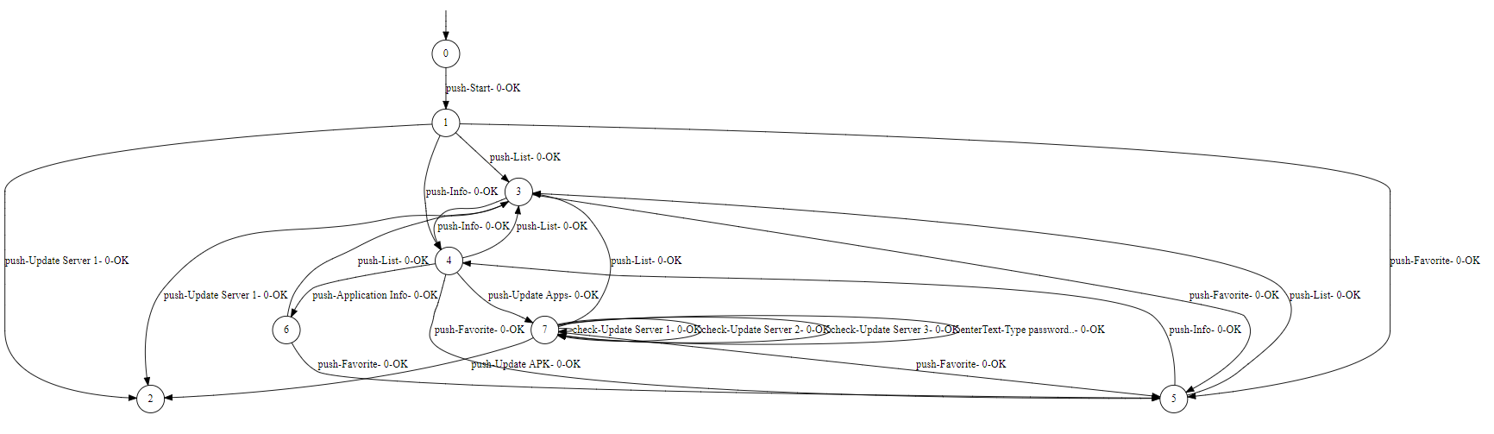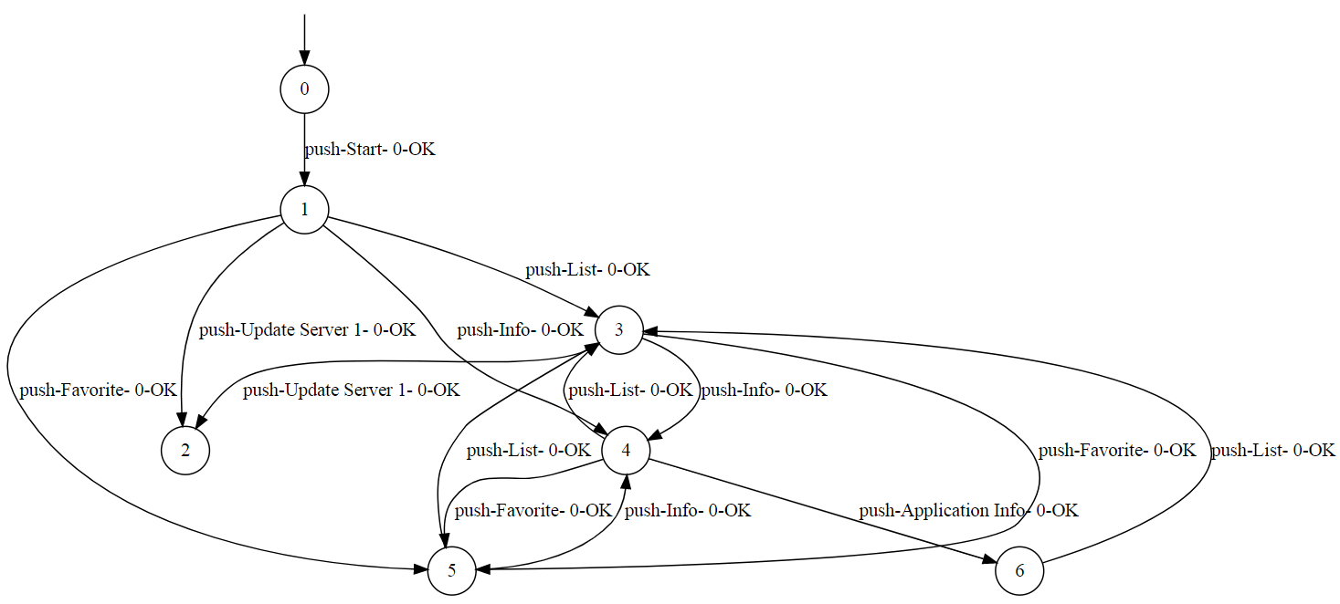

Real WhatsApp:

|  |
| --- |
| Wmethod |
| digraph g {  __start0 [label="" shape="none"];  s0 [shape="circle" label="0"];  s1 [shape="circle" label="1"];  s2 [shape="circle" label="2"];  s3 [shape="circle" label="3"];  s4 [shape="circle" label="4"];  s5 [shape="circle" label="5"];  s0 -> s1 [label="push-camera_btn- 0-OK"];  s0 -> s0 [label="push-tab- 0-OK"];  s0 -> s2 [label="push-tab- 0-OK"];  s0 -> s3 [label="push-tab- 0-OK"];  s0 -> s4 [label="push-contact_photo- 0-OK"];  s0 -> s1 [label="push-Meer opties- 0-OK"];  s2 -> s0 [label="push-tab- 0-OK"];  s2 -> s1 [label="push-tab- 0-OK"];  s2 -> s3 [label="push-tab- 0-OK"];  s2 -> s1 [label="push-Meer opties- 0-OK"];  s3 -> s0 [label="push-tab- 0-OK"];  s3 -> s2 [label="push-tab- 0-OK"];  s3 -> s1 [label="push-Meer opties- 0-OK"];  s4 -> s5 [label="enterText-entry- 0-OK"];  s4 -> s1 [label="push-Meer opties- 0-OK"];  s5 -> s1 [label="push-Meer opties- 0-OK"];  __start0 -> s0;  } |

